

College of Engineering

Department of Electrical and Computer Engineering

**System Description Report**

**Low Voltage Power Supply**

**Team Motorvators(Team 20)**

**Cyrus Yousefian, Pamela Gallardo, Tyler Chu, Joseph Fraticelli, and Bader Alshammari**

Meet the team

**Table of Contents**

|  |  |
| --- | --- |
| **Criteria** | **Page(s)** |
| Executive Summary: | 4 |
| Functionality: | 5 |
| Inputs & Outputs: | 5 & 6 |
| Use Case: | 6 |
| Physical Description & UI: | 7 – 9 |
| Development vs Procurement: | 10 – 12 |
| Specifications: | 1. – 14 |
| Validation by Test: | 15 -17 |

# Executive Summary:

The Low Voltage Power Supply (LVPS) for the Aztec Electric Racing (AER) vehicle is a Printed Circuit Board (PCB) enclosed in a modular, compact, fireproof, waterproof, and easy to assemble/disassemble enclosure. The purpose of the LVPS is to supply power to all onboard low voltage electronics on the AER vehicle via the use of an onboard low voltage battery pack. To achieve this, the PCB will be divided into five main circuits: battery management system (BMS), DC input for recharging the cells of the battery pack, dual voltage DC output, user interface (UI), and information logging. The BMS mainly consists of a microcontroller in the form of an ESP32 from the Wrover family of products and a BMS IC which will handle cell balancing and battery protection features. The DC input will be handled by an AC-DC wall power adapter which brings power to the PBC via a barrel jack. The dual voltage DC output will be handled by DC-DC converts that will create two voltage rails, 12V and 24V, the rails will be able to deliver up to 5A and 10A respectively. The UI will consist of a display and momentary switch on the front of the LVPS. The display will give the user information regarding battery performance and system power draw. The user will be able to request the logging of system information via the momentary switch located on the front of the LVPS. The logs will be written to an onboard SD card for the user to be able to review later. The following sections of this document cover functionality, inputs & outputs, use case, physical description & UI, development versus procurement, specifications, and validation in detail. In the next section, we will be exploring the functionality of the LVPS device.

# Functionality:

The Motorvator’s Low Voltage Power Supply is a compact and rechargeable, dual-output power supply that will assist the Aztec Electric Racing team by powering the vehicle’s on-board, low-voltage electronics during competition. The internal battery management system protects the power supply against short circuits, overcharging and over-discharging, and damage from high temperatures. The microcontroller interfaces with the BMS integrated circuit through the I2C protocol and data bus to extract and process power supply data, namely voltage, current, and temperature. This data will be sent to the built-in display to indicate when the power supply must be charged and to allow the AER team to determine the near real-time status of the device. As a backup, the microcontroller will also write this data to a log in the micro-SD card at the behest of the user.

# Inputs & Outputs:

As an external input, The AC-DC wall adapter provides direct current to the battery cells, allowing for easily rechargeable functionality from any standard North American 120V wall outlet. As an external output, the six 18650 lithium-ion battery cells shown in the diagram of the device outputs 24V at a max of 10A and 12V at a max of 5A to the AER race car’s low-voltage electronics. Internally, these cells also supply 3.3V to power the ESP32 microcontroller through the ground and header pins as well as supplying 3.3V to the TI-BQ769 series BMS IC through the wires outlined in the diagram. The BMS outputs digital data encompassing voltage and current levels as well as temperature to the data bus from which the microcontroller reads and processes using the I2C protocol. The microcontroller then outputs this digital data to a micro-SD breakout board using the serial peripheral interface (SPI) protocol. This micro-SD card stores power supply information that can be extracted and read through an external computer. The microcontroller is also responsible for outputting the digital data to the LCD screen for display using the I2C protocol once again.

# Use Case:

The Low Voltage Power Supply for an Electric SAE Race Car (change this) is being developed to power all low voltage electronics on the vehicle (instrument cluster, PCM, etc). Prior to our project, there was an existing model, however, it was very inconvenient in many aspects for Aztec Electric Racing. For example, there were rechargeable batteries, however, in order to charge them it required desoldering wires and hooking up a benchtop power supply. This is not very practical, as a power adapter would be more sufficient for rechargeability, allowing the racers to plug the power supply into the wall when charging is needed. With practicality in mind, the design should not have to be tampered with in order to perform essential functions such as charging. In past competitions, the power supply used buzzers to indicate it was “on” and functioning correctly, with no method of collecting how effective/efficient the batteries were working together. For testing purposes, the chassis will include a display providing information about the batteries, such as temperature, voltage, and current output. In addition to displaying information, there will be an SD Card that will store the data. By collecting data, we are able to go “back to the drawing board” to fine-tune the design, comparing the data after each design change.

# Physical Description & UI:

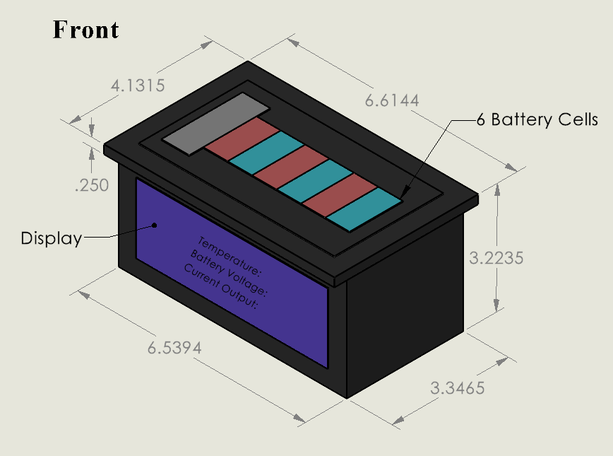

Figure 1 Front of device (measurements in inches) showing UI and location of battery cells

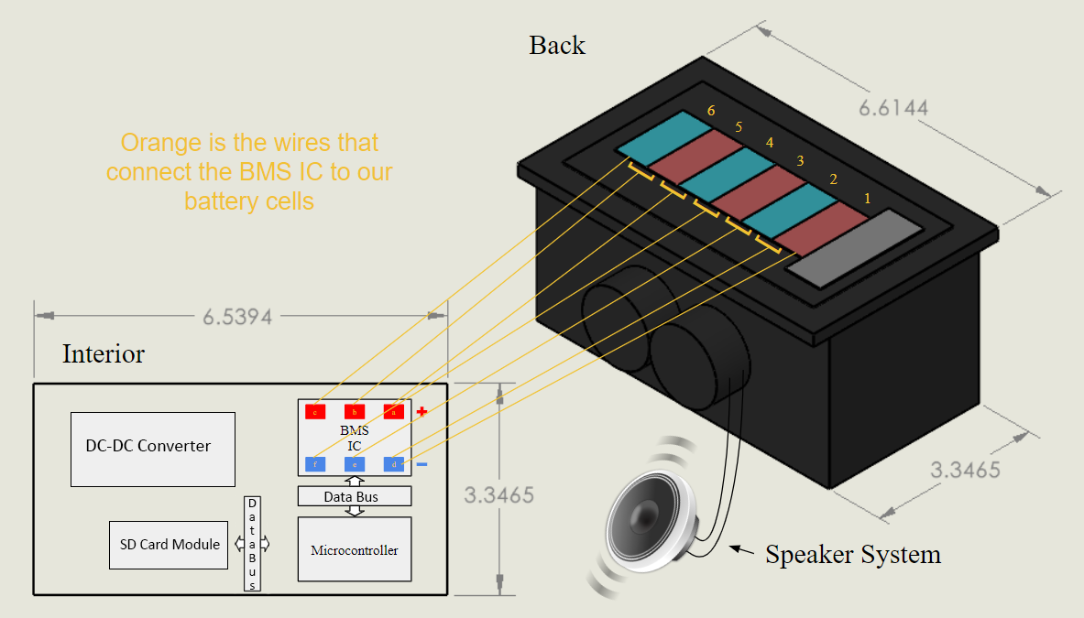

Figure 2 Back of device (measurement in inches) Showing interior where PCB is and parts of PCB and how the battery cells connect to the PCB

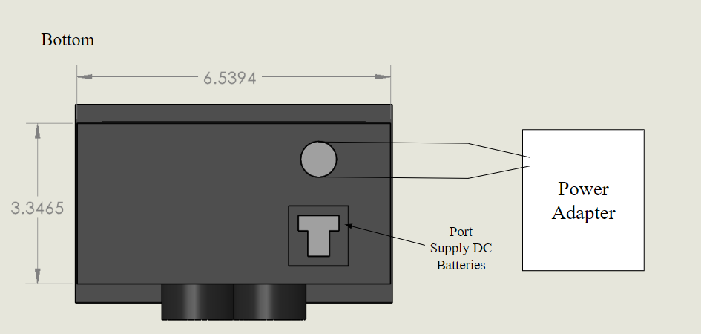

Figure 3 Bottom of device showing DC output and DC input

# Development vs Procurement:

The low voltage power supply will be built about inside 3.4 inches by 6.7 inches container to follow FSAE Rule guidelines, and we have a budget of 1,000 dollars. The battery management system inside the container powers on the dual output for 24 V at max 10 A and 12V max 5A. The components procured for the low voltage power supply include BMS (Battery Management) IC (Integrated Circuit), ESP 32-S2 Development Kit, cell stacks, data bus, power adapter (AC-DC wall adaptor), dual port to power the SAE race car, SD card, SD Card module, and voltage regulator. We will also procure additional subcomponents needed to support the main components, including power MOSFETs, current sense resistors, resistors, thermistor, fuse holders, LCD, wire, momentary switch, Schottky diodes, complementary capacitors, barrel jack, and Deutsch connector. We will develop our own embedded software to control and support components like the ESP 32 microcontroller, data bus, and potentially our android app.

## BMS IC

Our BMS (Battery Management system) has multiple requirements, including battery cell charging, battery cell discharging, and temperature readings of the battery cells, and to be able to meet these requirements, we need to procure the BMC IC. The BMS IC has EEPROM (Erasable Programmable Read-Only memory) capabilities and a control unit that will be needed as part of our development to store information like displaying temperature readings, and it’s also compatible with our microcontroller. Also, building our BMS through the assistance of essential components like BMS IC allows us to become more familiar with Battery Management Systems.

## ESP 32-S2 WROVER Development KIT

Our low-voltage power supply needs a microcontroller compatible with our BMS IC. The ESP 32-S2 WROVER development kit will be procured one of the reasons being because the ESP32-S2 WROVER Development kit is compatible with our BMS IC. Also, the ESP32-S2 WROVER can be configured to provide functionalities needed for our development, including ADC and DAC. Also, The ESP 32-S2 WROVE development kit comes with an ESP 32-S2 module that SoC with IO capabilities and 4MB of Flash, and 2MB PSRAM. Another benefit of this development kit is that we can provide the reflashable firmware we develop to the SAE team if they want to replace the MCU in the future. Also, while we can technically make our own microcontroller from scratch that would distract from our objective of being able to build and maintain our BMS.

## Lithium-Ion cell stacks

We will procure more than 6 Lithium cell stacks because the BMS IC that we purchase depends on Lithium cell stacks. Also, the capacity of the batteries we need is about to ensure that the Low Voltage Power supply can be used during competition.

## Data bus

We will develop/implement various data buses on our PCB (Printed Board Circuit) to interconnect our (slave) devices, including the BMS IC, SD Card Breakout Board, and display to the ESP32-S2 Development Kit (Microcontroller) host device.

## Dual output Port to power SAE race car

The battery management system inside the container powers the dual output port, which powers the SAE race car’s low voltage electronics at 24 V at max 10 A or 12V max 5A. The container (that will house the BMS) already has a dual output Port, so we do not need to procure or develop the output port.

## DC to DC Conversion

We will procure a DC-to-DC Convertor to control the voltage and current, which will serve as a dual output to charge the car for 24 V at max 10 A and 12V max 5A, which will be done by splitting the voltage of the batteries into two different rails. Therefore, we will procure a DC-to-DC Convertor because our Low Voltage Power supply must have dual output capabilities.

## Power Adapter (AC to DC wall Adapter)

We will procure an AC Power Adapter, which will be needed to recharge the batteries.

## MicroSD card

We will procure a MicroSD card to read and collect data like the voltage, current, and temperature. The MicroSD is inexpensive and needed to collect and read data for our Low Voltage Power Supply Project.

## SD Card Module

We will also procure an SD Card Module to facilitate the connection between our Micro SD card and Microcontroller.

# Specifications:

The device must be capable of supplying at .

The device must be capable of supplying at .

The device shall be powered by rechargeable batteries.

The device must be capable of operating on a single charge during the entirety of a competition event.

The device must have a battery management system with the below protection features:

* Short circuit protection
* Over-charge protection
* Over-discharge protection
* High-temperature protection

The device shall be equipped with a display.

The display must provide the user with the following information:

* Battery temperature
* Battery voltage
* Current output

The device shall be equipped with an SD card reader.

The device must be capable of logging battery temperature, battery voltage, and current output to the SD card, at the behest of the user.

The batteries in the device shall be recharged via the use of an external AC wall power adapter.

The device must be housed in a modular, compact, fireproof, waterproof, and easy to assemble/disassemble enclosure, supplied by the ME team.

# Stretch Specification:

The device must be Bluetooth enabled.

The device shall be accompanied by an Android application.

The accompanying Android application must be capable of interfacing with the device via the use of Bluetooth technology.

The user must be able to log battery temperature, battery voltage, and current output via the use of the accompanying Android application.



Table 1: Device component breakdown for better visualization

# Validation by Test:

To validate that our device can supply at , we will connect the output of the rail to a load. We will have two digital multimeters (DMM), one in parallel to the load to measure the voltage across it and one in series to measure the current. If we get and on the respective DMMs then we have met the specification.

To validate that our device can supply at , we will connect the output of the rail to a load. We will have two DMMs, one in parallel to the load to measure the voltage across it and one in series to measure the current. If we get and on the respective DMMs then we have met the specification.

To validate that our device can operate on a single charge for the duration of one race. We will discharge the device for minutes, the longest time of a race, by applying a load to the rail and a load to the rail. After minutes have elapsed, we will measure the voltage of the battery pack using a DMM in parallel. If the voltage of the two rails is still and , then this specification is validated.

To validate the short circuit protection feature, we will probe the gate and source of the discharge power field effect transistor (FET), using a DMM. We will short the and connections together. If we see of the discharge FET drop below , the specification is validated.

To validate the over-charge protection feature, we will begin charging the batteries of the device, via the AC wall power adapter. We will monitor the voltage of each cell by having a DMM in parallel. Using a DMM, we will probe the gate and source of the charge power FET. Once the voltage of the cells reaches , if of the charge FET is less than the , the specification is validated.

To validate the over-discharge protection feature, we will begin discharging the batteries of the device, by applying a load across and . We will monitor the voltage of each cell by having a DMM in parallel. Using a DMM, we will probe the gate and source of the discharge power FET. Once the voltage of the cells reaches , if of the discharge FET is less than the , the specification is validated.

To validate the high-temperature protection feature, we will begin discharging the batteries of the device, by applying a load across and . Using a DMM, we will probe the gate and source of the discharge power FET. We will apply hot air to the thermistor attached to the battery pack. Once is achieved, if of the discharge FET drops below , the specification is validated.

To validate logging info to the onboard SD card, we will request the system to log the battery temperature, battery voltage, and current output. We will then apply various loads across the rail and the rail. We will then request the system to stop logging. We will remove the SD card from the device and read the contents using a PC. If the contents are not NULL and seem to be feasible values, the specification is validated.

# Validation by Inspection:

We will look at the display to see if it is displaying battery temperature, battery voltage, and current output. If it is, then the spec is validated.

We will look at the device to see that rechargeable batteries are powering it. If it is, then the spec is validated.

We will look at the device and ensure that its method of recharging the batteries is via the use of an external AC wall power adapter. If it is, then the spec is validated.